User Manual

Whatsapp Broadcast Portal

Registration & Login:

1. The user should register for an account with a unique username and provide their name and a secure password.
2. The user should then login using his credentials to access the different pages in the Whatsapp Broadcast Portal.
3. The user can logout at any time he wants using the logout button. It is recommended to log out after each session, especially on shared devices.

The Whatsapp Broadcast Portal includes four pages:

* Home Page: Contains basic information about the portal.
* Settings Page: Where the user enters his information and required settings.
* Contacts Page: Where the user’s contacts are stored in a table.
* Broadcast Page: Where the user can send broadcasts to their selected contacts.

Settings:

1. To setup the Settings Page, the user must first create an account on [Maytapi](https://maytapi.com/) and register a phone number.
2. The user should then enter his Name, Email and Address which will not be verified by the settings page.
3. The user should the open the [Maytapi Console](https://console.maytapi.com/) and enter the phone’s ID in the Phone ID row and his registered phone number in the Phone Number row with the country code, without any special characters (e.g., + or ()) or spaces (e.g., 96170123456 or 9613123456 for Lebanese Numbers starting with 03 the 0 should be removed).

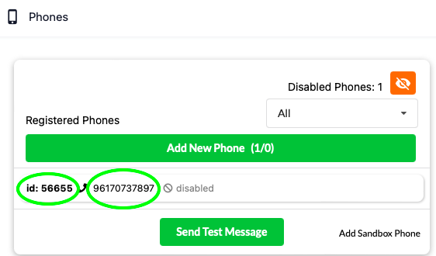

1. The user should open the Product ID & Token Page under the Developers tab, and copy and paste the Product ID into the Product ID row and the Token into the Token row.

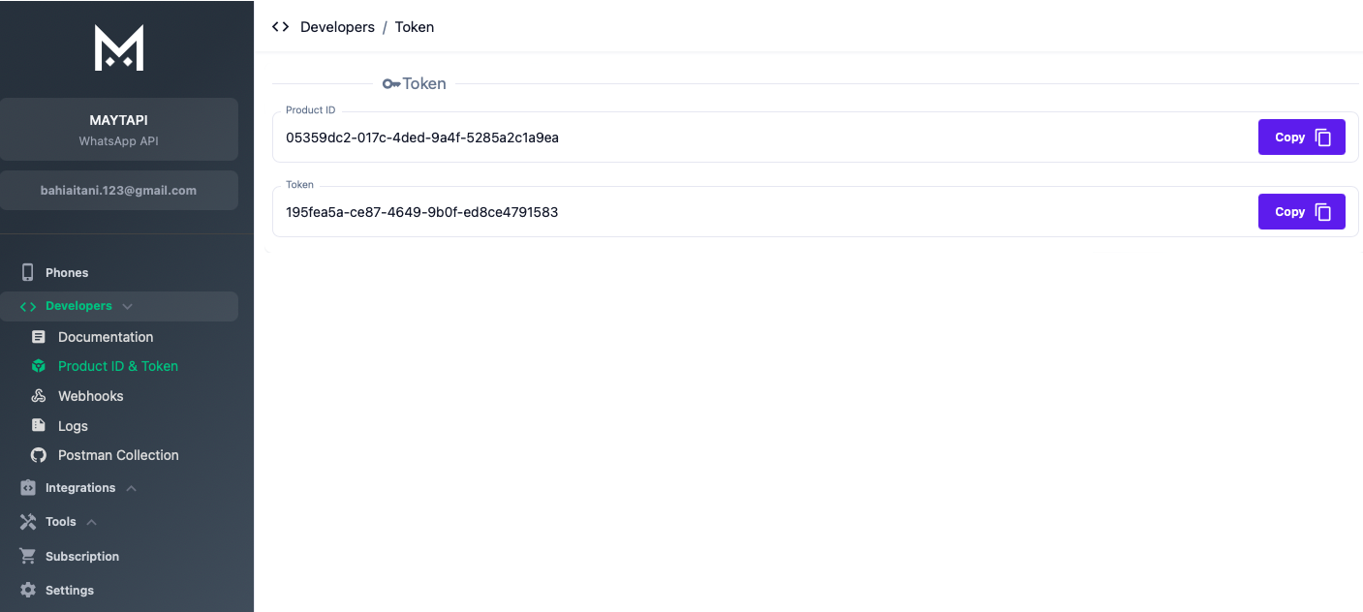

1. The user should then press the Save button, and a popup will show the status of verifying the four fields: Product ID, Token, Phone ID and Phone Number. If there is an error, retry after double-checking your information, as all fields are required to save the settings.

Contacts:

1. The user can add contacts manually or can import contacts. Contacts can be edited and deleted.
2. To add contacts manually, the user has to enter the name of the contact, phone number of the contact with the country code (without any special characters or spaces, e.g., 96170123456 or 9613123456 for Lebanese Numbers starting with 03 the 0 should be removed) and the address of the contact. All fields are required, and duplicate contacts with the same phone number are not allowed.
3. To import contacts, the user should submit an XLSX or a XLS file with Name of the contact column labeled as “Display Name”, the Phone Number of the contact column labeled as “Mobile Phone”, and the Address of the contact column labeled as “Address”.

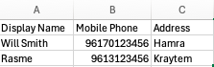

1. Contacts with bad formats will not be imported but will not be able to be sent broadcast unless the format is edited in the contacts’ table. The phone number of the contact must be entered with the country code, without any special characters (e.g., + or ()) or spaces (e.g., 96170123456 or 9613123456 for Lebanese Numbers starting with 03 the 0 should be removed).

Broadcast:

1. To send a broadcast, the user should select the contacts they want to send to using the checkbox, enter a message, or choose a file, or enter a message and choose a file to be sent together.
2. The user should press the Send Broadcast button, and the messages will be sent. The broadcast status will be displayed.

## General Navigation:

* Use the navigation bar at the top of the page to switch between the Home Page, Settings Page, Contacts Page, and Broadcast Page.

## Security Tips:

* Create a strong password that includes a mix of letters, numbers, and special characters.
* Keep your password secure and do not share it with anyone.
* Always log out after each session, especially when using a shared device.

## Error Handling:

* If you encounter errors during the verification of Product ID, Token, Phone ID, or Phone Number, double-check the entered information and your subscription (e.g., status of phone number) and try again.
* If the error persists, contact support for further assistance.

## Contact Support:

* If you face any issues that you cannot resolve, please contact our support team at [EDM](https://edm.com.lb/contact-us/).

## File Formats for Import:

* Ensure your contact import file is in XLSX or XLS format.
* Use the following column labels: "Display Name" for the contact's name, "Mobile Phone" for the contact's phone number, and "Address" for the contact's address.
* The phone number of the contact must be entered with the country code, without any special characters (e.g., + or ()) or spaces (e.g., 96170123456 or 9613123456 for Lebanese Numbers starting with 03 the 0 should be removed).



## Privacy and Data Handling:

* We are committed to protecting your data and ensuring your privacy.
* Your contact information is stored securely and is only used for the purposes of the WhatsApp Broadcast Portal.
* We comply with relevant data protection regulations.